SW-18010P Vibration sensor

Overview :
SW18010P Vibration Sensor Module Normally Open Type Vibration Switch Alarm Sensor Module for Arduino . The SW-18010P Vibration Sensor Module is a compact and cost-effective module used to detect vibrations and sudden movements. It is commonly used in anti-theft alarms, robotics, and electronic DIY projects.

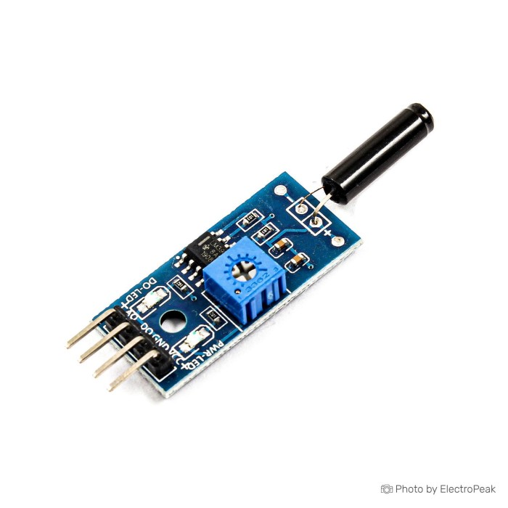

Module Usage :

What we can use it for:
- Detecting vibrations to trigger:
  - Anti-theft alarms (e.g., if someone moves or hits your bike, car, or door)
  - Intelligent vehicles (e.g., shock detection in robots)
  - Electronic DIY projects (like learning kits or security toys)

- When the sensor detects a big shock or vibration, it sends a signal — but only for a very short time (milliseconds).
- This short pulse is not enough to directly control a relay, which usually needs a longer, stable signal to switch ON.

Module description:
1.Using the company's high-sensitivity vibration switch SW-18010P, standard with vibration sensors.
2. The comparator output signals are clean, good waveform, driving ability, less than 15mA
3.Working voltage from 3.3V-5V
4. the output form: digital switching output (0 and 1)
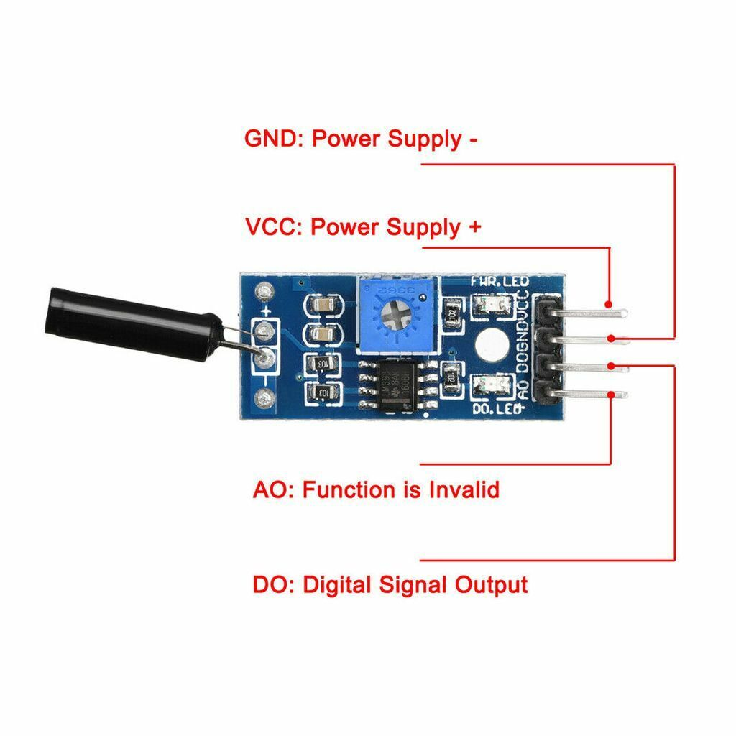
5. a fixed bolt hole for easy installation
6. Small PCB size: 3.2cm x 1.4cm
7. using a wide voltage comparator LM393

Module wiring instructions:

VCC: positive power supply
GND: negative
DO: digital signal output
AO: With this shock sensor, this function is invalid

Module description:

- When the product does not shock, vibration switch OFF status, the output of high output, the green light is not on;
- When the product is shock, the vibration switch will be immediately turned on, output of low output, the green indicator light;
- The output can be directly connected to the microcontroller through the microcontroller to detect high and low, thus detecting whether the environment has vibration, play a role in police

